*Question 1* - Fun with Polymorphism  
  
Create a hierarchy of shapes with the classes Shape, Circle, Rectangle and Square. (*Hint: Square is a special Rectangle whose length=breadth*)

Each class has its own printDescription() method which prints its dimensions and area.

Create a ShapeManager class which instantiates the various shapes and calls for the description of each shape using the method manageShape(Shape).

void manageShape(Shape myShape)  {

    myShape.printDescription();

}

The constructors of the other classes are as  follows:

* Circle(double radius)
* Rectangle(double length, double breadth)
* Square(double side)

Declare the constructor of each class with a print statement.

Shape()  {  
    System.out.println("Default constructor of Shape");   
}

Shape(...)  {  
    System.out.println("Constructor of Shape with parameters xyz");   
}

*Question 2* - Who Am I?

Construct the following inheritance hierarchy.

[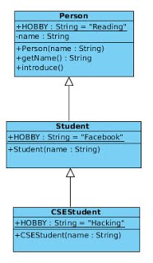](https://sites.google.com/a/iemcal.com/cs504d-oop/labs/PersonHierarchy.jpg?attredirects=0)

A typical way to introduce oneself is "Hello, my name is xxx and my hobby is yyy".   
(*Hint: use a combination of the getName() method and the HOBBY String constant*)

Arif is a CSE Student at IEM, who secretly moonlights as a hacker.  Have Arif introduce himself

(1) at a get-together for student leaders of various colleges in Salt Lake

(2) at a closed-door Hacker Society meeting

(3) at his cousin's birthday party where he meets a beautiful girl who is a Tagore fan.

*(Hint: Instantiate Arif as a CSEStudent, then use a switch case for his different behaviour e.g. choice #2 implies Arif is at the Hacker Society Meeting.*)  
(*Hint: Use the super keyword*; you may also introduce additional methods)